Unit 10 Assignment Instructions – CIS164 
For the Unit 10 Assignment we will be working with files, to include the ability to read from and write to files with Python. We will also be reviewing how to organize files within your Operating System with Python. This will include the ability to copy, move, and delete files.
Please make sure to fully read each question to ensure that you answer each question per the requirement. Also, please ensure that all responses are in complete sentences, free of spelling and grammatical errors.
*Unit 10 Grading Rubric (45 Points):
Assignment Requirements | Maximum Points | Points Earned
1. Reading and Writing Files | 0-20 Points
2. Organizing Files | 0-25 Points
Points Deducted for Spelling or Grammatical Errors
Total (Sum of All Points)
*Directions for Submitting Your Assignment:
Complete your assignment ensuring all questions are answered based on the assignment requirements. When the Unit 10 assignment is complete, please save your file in the following format, “Lastname-Unit#.doc” (Example: Smith-Unit10.doc). You may also utilize a Word Processing software such as LibreOffice for assignment completion. In this case the assignment may be saved in .odt format, (Example: Smith-Unit10.odt). Then when ready submit your file to the “CIS 164 – Unit 10 Submit Assignment” activity for grading.

1. Reading and Writing Files
- Start the PyCharm IDE. Select “File->New Project” on the next screen then under “Location” change the word “untitled” to “Unit10”. Then click the “Create” button.

- Highlight your project “Unit10” then right click. When you right click a menu will appear, from this menu select New->Python File. Then a dialog box will appear, in the “Name” field of the dialog box type “Unit10Files1.py”.

- Highlight your project “Unit10” then right click. When you right click a menu will appear, from this menu select New->File. Then a dialog box will appear, in the “Enter a new file name” field of the dialog box type “test123.txt”. Then when the test123.txt file has been created, within the file enter the following, “I love Python programming!”. Provide a screenshot
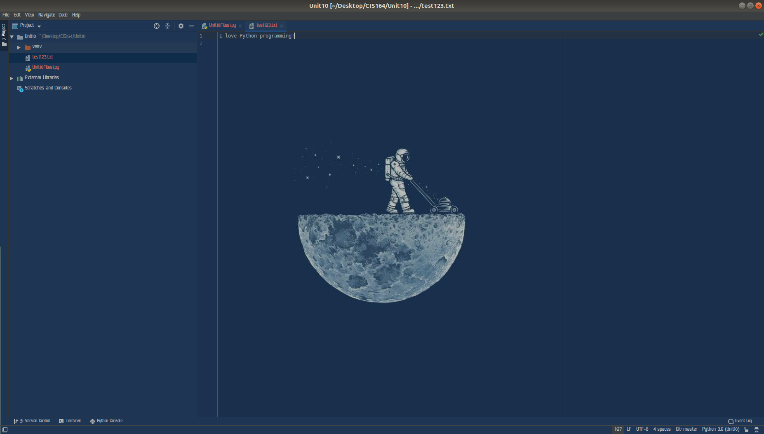
- Within your “Unit10Files1.py” file configure your script to read the newly created “test123.txt” file above and display its contents as a single string value.

- You will then need to provide a screenshot showing your completed script.
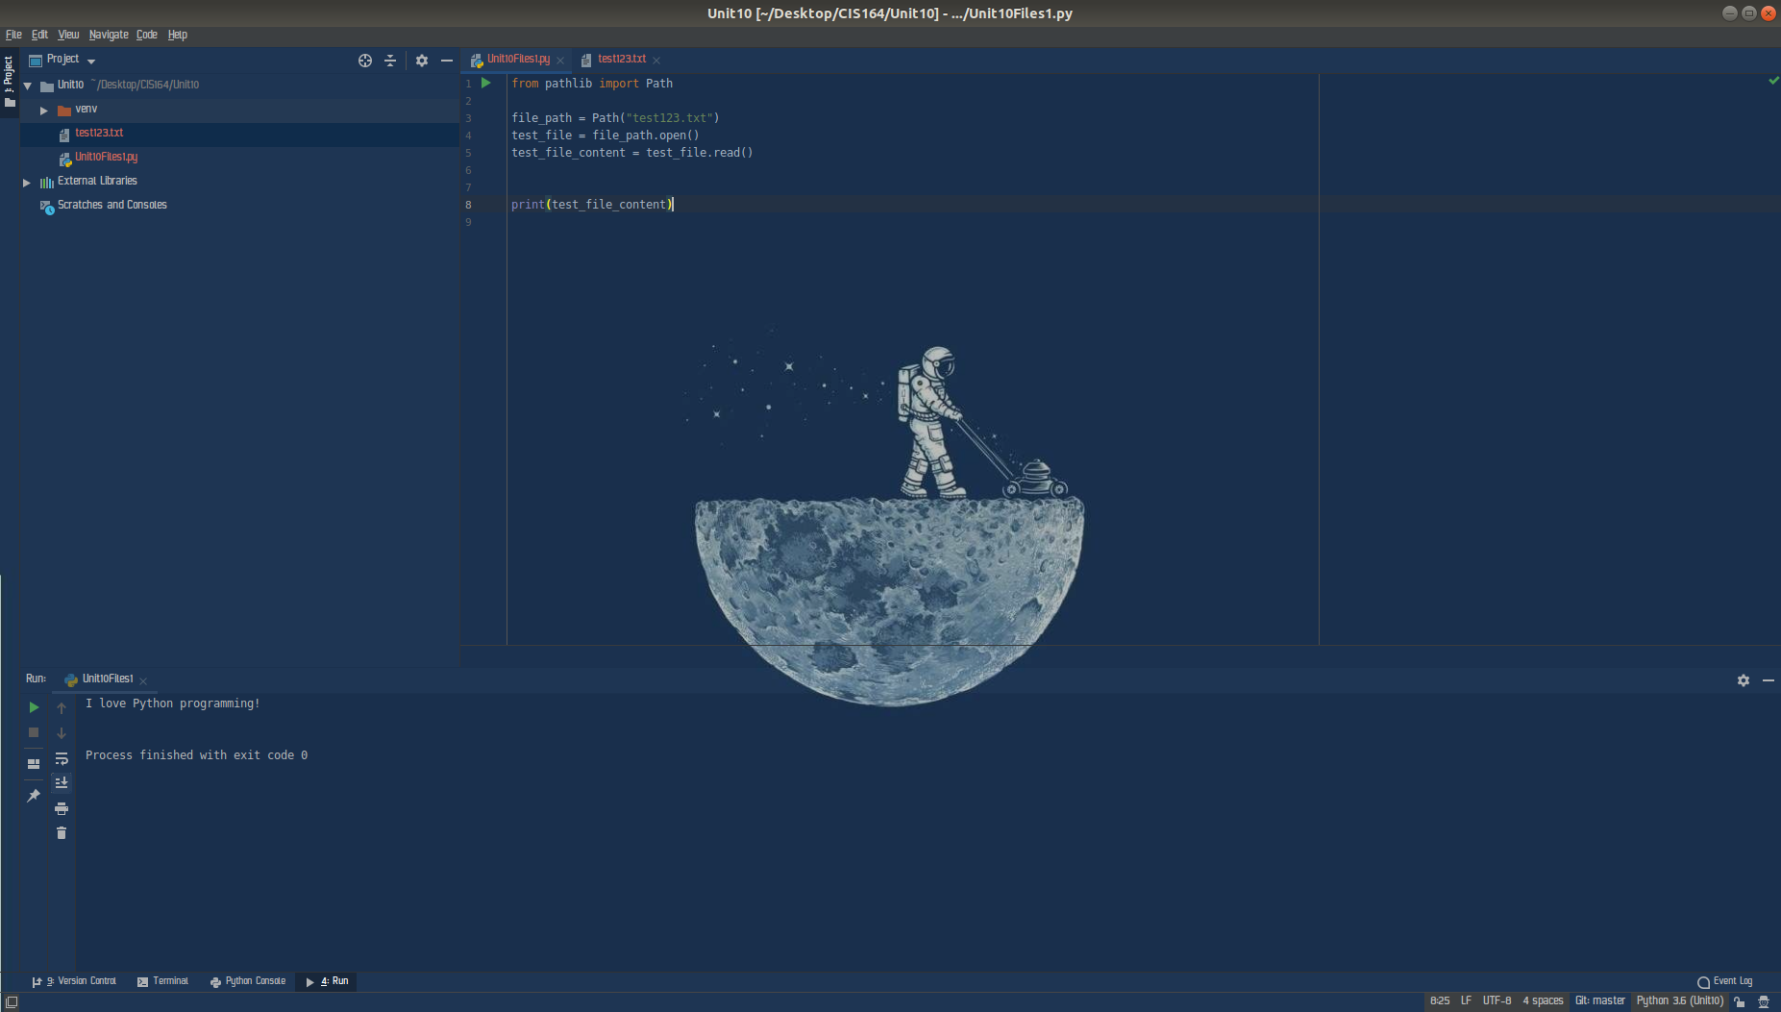
- Next, modify your “Unit10Files1.py” file to append to the file “test123.txt” created above, to add ‘Python is the best!’ to the file.

- For your script, you will need to provide a screenshot showing your completed script, and you will also need to submit it in a text file, along with this document.
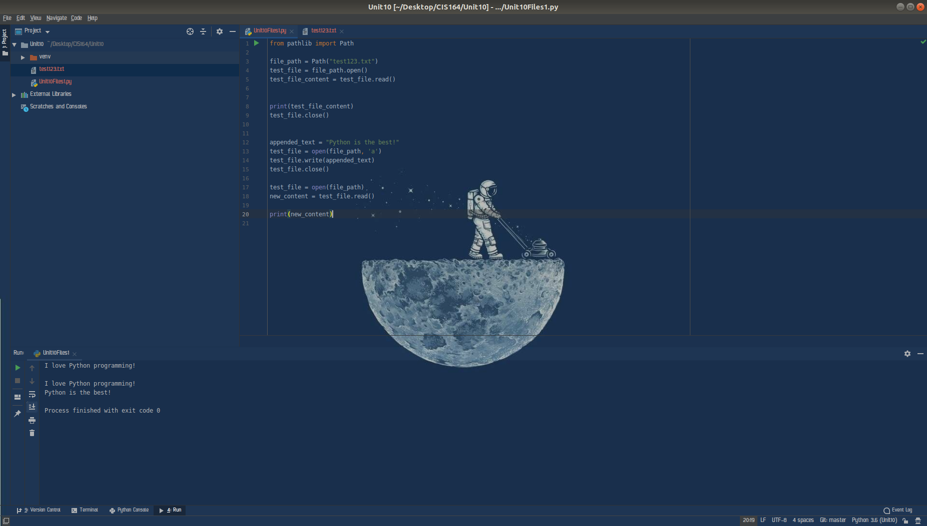

2. Organizing Files
- Highlight your project “Unit10” then right click. When you right click a menu will appear, from this menu select New->Python File. Then a dialog box will appear, in the “Name” field of the dialog box type “Unit10Files2.py”.

- Within your “Unit10Files2.py” file configure your script to display your current working directory by utilizing the os library for Python.

- Within your “Unit10Files2.py” file next configure your script to copy the file “test123.txt” that was created in the first section of this assignment to be renamed as “test321.txt” by utilizing the shutil library.
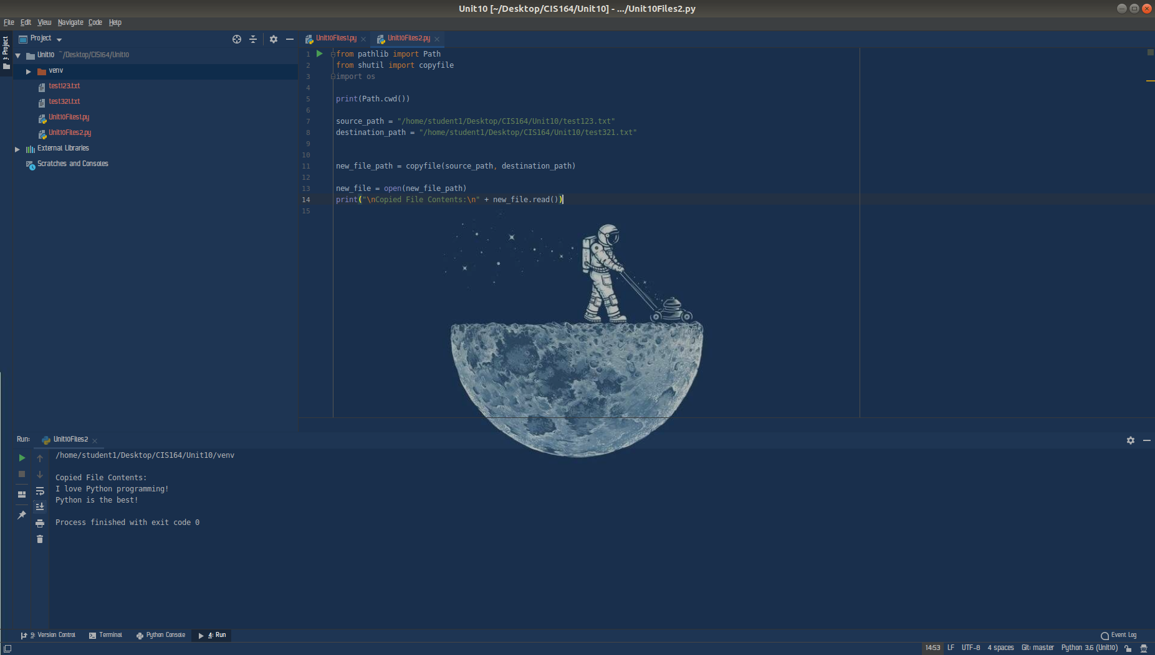

- Within your “Unit10Files2.py” file next configure your script to delete the file “test123.txt” by utilizing the os library.

- Within your “Unit10Files2.py” file, configure your script to delete the file “test321.txt” by utilizing the send2trash library.
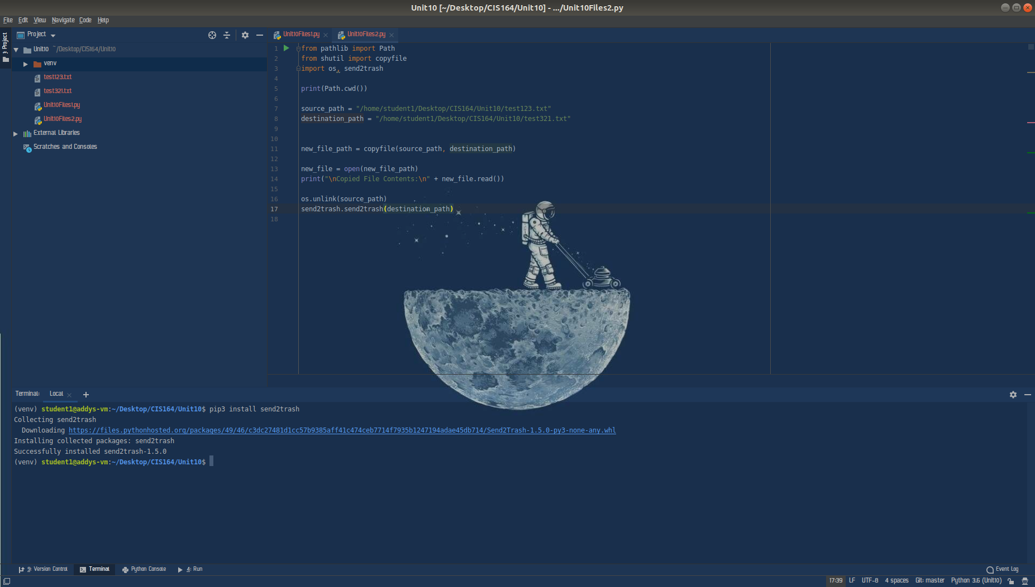
**Note: For importing ‘send2trash’, you will need to complete the following.**

If you are using PyCharm, you will need to complete the following steps:
If you already have the ‘run’ console displayed on the bottom of PyCharm, you can simply go to the bottom left of your PyCharm screen and click ‘Terminal’, it will be two over from ‘Run’. If you do not have the ‘run’ console displayed, you click from the PyCharm menu, View->Tool Windows->Terminal. The goal will be to have a terminal display within PyCharm with a path displayed for your Unit 10 project. Then you will type:

pip3 install send2trash

This will install the send2trash module for you in Python3 and allow you to import and use it in your script!

If you are not using PyCharm, you will need to open a Linux terminal then type the following:

sudo apt update
sudo apt install python3-pip
pip3 install send2trash --user

- Provide a screenshot showing your completed script, which will include all of the tasks in section 2, and you will also need to submit your script in a text file, along with this document.

